Mop MGR
PRE-CHANGE
↓
1. Capture baseline
↓
2. Confirm active/standby
ceph-master.ezhuly ACTIVE 16.2.5
ceph-node3.eniabu STANDBY 16.2.5
↓
3. Validate quay.io/ceph/ceph:v16.2.15
↓
4. orch upgrade check
↓
5. Freeze balancer / autoscaler nếu cần
↓
6. Capture migration_current
↓
7. Create checkpoint
↓
────────────────────────────────
CANARY MGR
────────────────────────────────
↓
8. Redeploy STANDBY
mgr.ceph-node3.eniabu
16.2.5 → 16.2.15
↓
9. Gate
active old healthy
standby target healthy
↓
10. ceph mgr fail ceph-master.ezhuly
↓
11. Verify node3 becomes ACTIVE 16.2.15
↓
12. Check migration/module/orch/
monitoring/workload/PG
↓
13. Observation window
↓
────────────────────────────────
ROLLOUT MGR
────────────────────────────────
↓
14. ceph orch upgrade start
--image ...
--daemon-types mgr
↓
15. Upgrade remaining MGR
↓
16. Both MGR = 16.2.15
↓
17. Post-check
↓
18. Restore balancer/autoscaler
to ORIGINAL state
↓
END MGR PHASE
- Trước tiên là nâng cấp standby
mgr: ceph-master.ezhuly(active, since 8m), standbys: ceph-node3.eniabu
export OLD_ACTIVE_ID="ceph-master.ezhuly"
export STANDBY_DAEMON="mgr.ceph-node3.eniabu"
export TARGET_IMAGE="quay.io/ceph/ceph:v16.2.15"
export TARGET_IMAGE="quay.io/ceph/ceph:v16.2.15"
export EVIDENCE="mgr-mop-20260930T093558Z"
- Baseline
umask 077
export EVIDENCE="$PWD/mgr-mop-$(date -u +%Y%m%dT%H%M%SZ)"
mkdir -p "$EVIDENCE"
ceph -s \
| tee "$EVIDENCE/01-ceph-s.txt"

ceph health detail \
| tee "$EVIDENCE/02-health-detail.txt"
ceph versions -f json-pretty \
> "$EVIDENCE/03-versions.json"
ceph mgr dump -f json-pretty \
> "$EVIDENCE/04-mgr-dump.json"
ceph mgr metadata -f json-pretty \
> "$EVIDENCE/05-mgr-metadata.json"
ceph mgr module ls -f json-pretty \
> "$EVIDENCE/06-mgr-modules.json"
ceph mgr services -f json-pretty \
> "$EVIDENCE/07-mgr-services.json"
ceph orch upgrade status \
| tee "$EVIDENCE/08-upgrade-status.txt"
ceph orch ps --refresh -f json-pretty \
> "$EVIDENCE/09-orch-ps.json"
ceph pg stat \
| tee "$EVIDENCE/10-pg-stat.txt"
ceph balancer status \
| tee "$EVIDENCE/11-balancer.txt"
ceph osd pool autoscale-status \
| tee "$EVIDENCE/12-autoscale.txt"
ceph crash ls-new \
| tee "$EVIDENCE/13-crashes.txt"

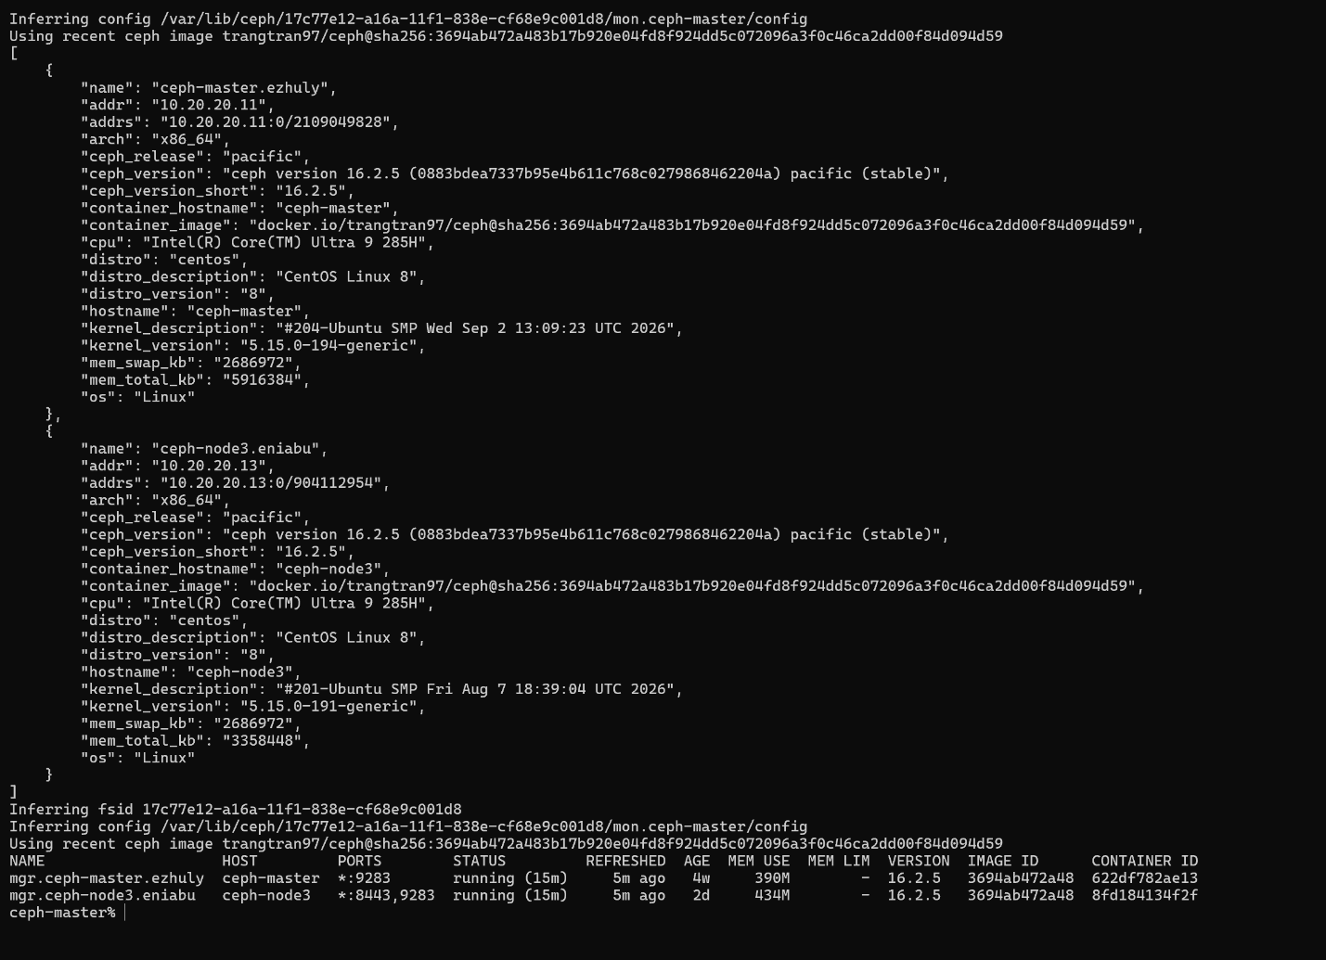
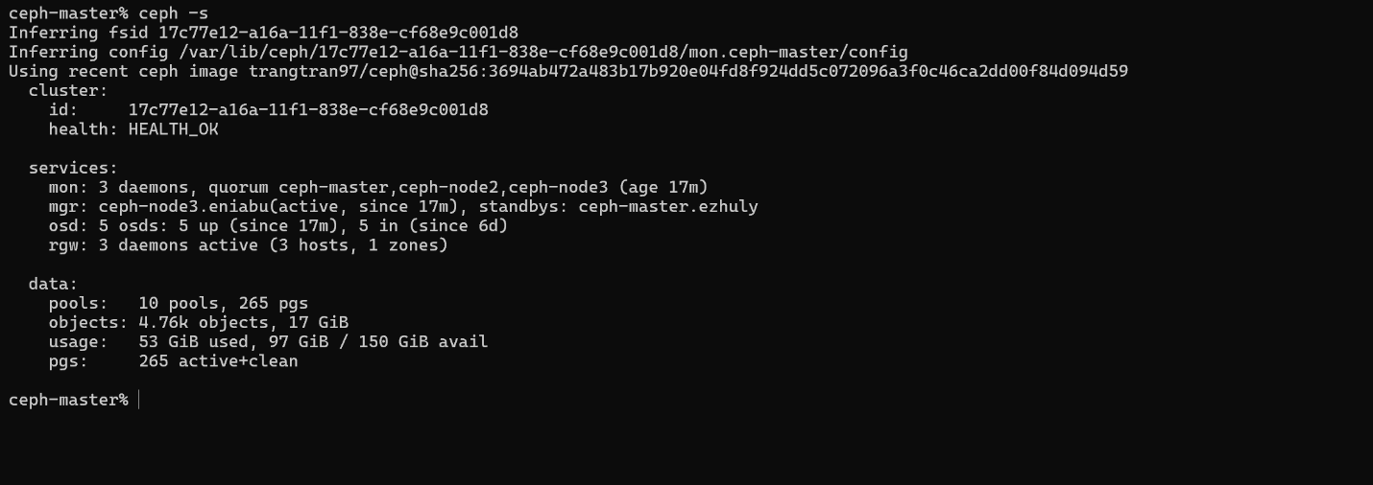
- Check xem standby là ai

Chạy test xem có những daemon nào phải nâng
ceph orch upgrade check --image "$TARGET_IMAGE"
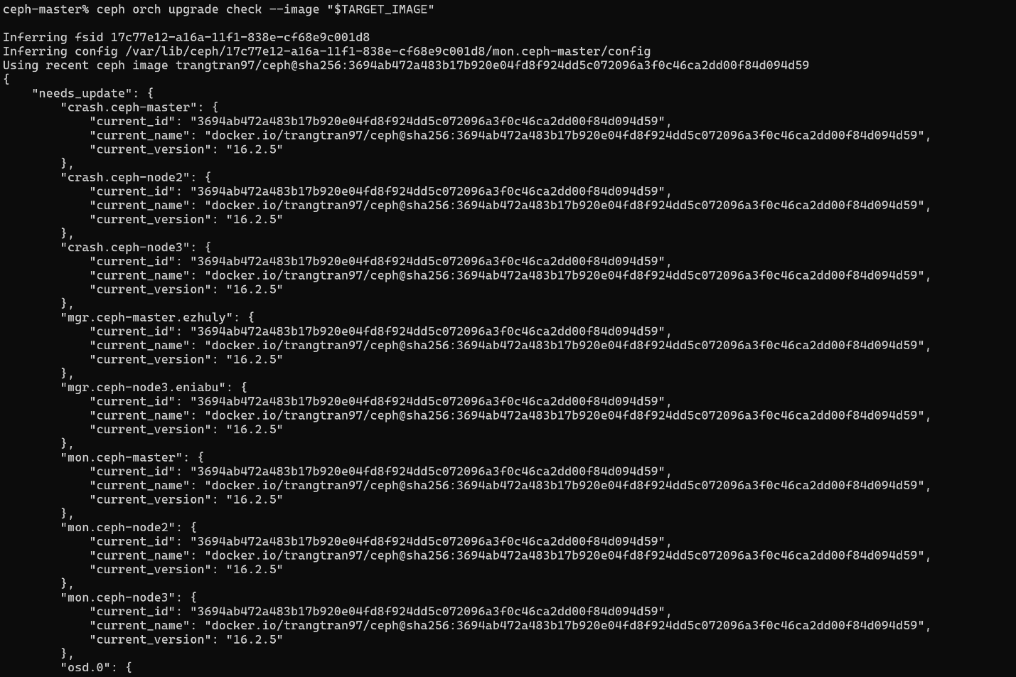
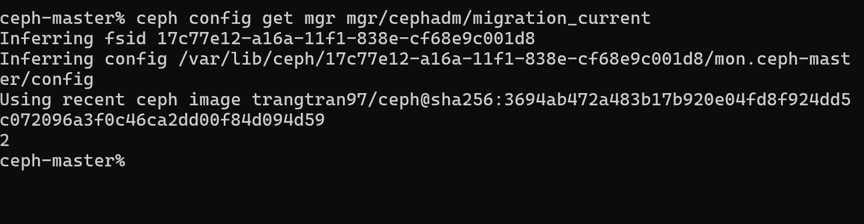

kiểm tra migration code
ceph config get mgr mgr/cephadm/migration_current

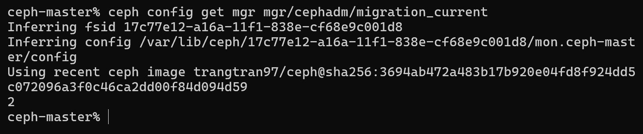

migration_current before = 2

Bắt đầu repdeploy với image mới

Cẩn thận nếu là active thì không được
15:30:29 Schedule redeploy daemon mgr.ceph-node3.eniabu
15:30:30 Failing over to other MGR
15:30:36 mgr.ceph-master.ezhuly ... Updating ...

Tại vì máy chủ host không đủ RAM nên là tcmalloc: large alloc 1073750016 bytes
MGR 16.2.15 không lên active ngay sau redeploy; nó đã chạy standby một thời gian rồi mới được promote.
16:39:06 mgr handle_mgr_map Activating!
16:39:06 mgr handle_mgr_map I am now activating
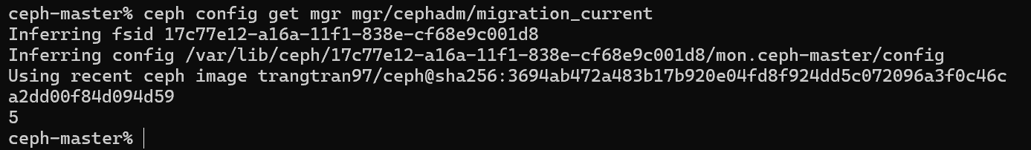

MGR 16.2.15 không chỉ chạy container thành công mà còn đã active và hoàn tất cephadm migration target.
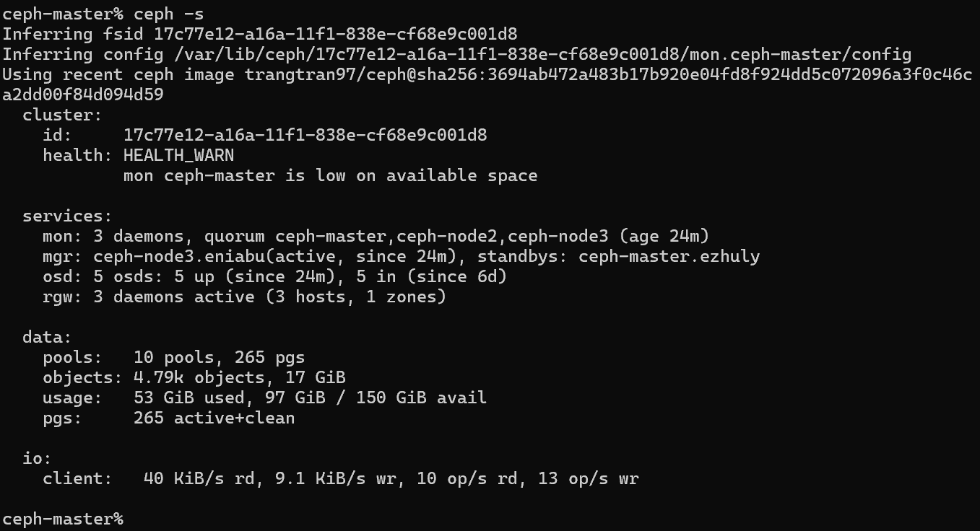


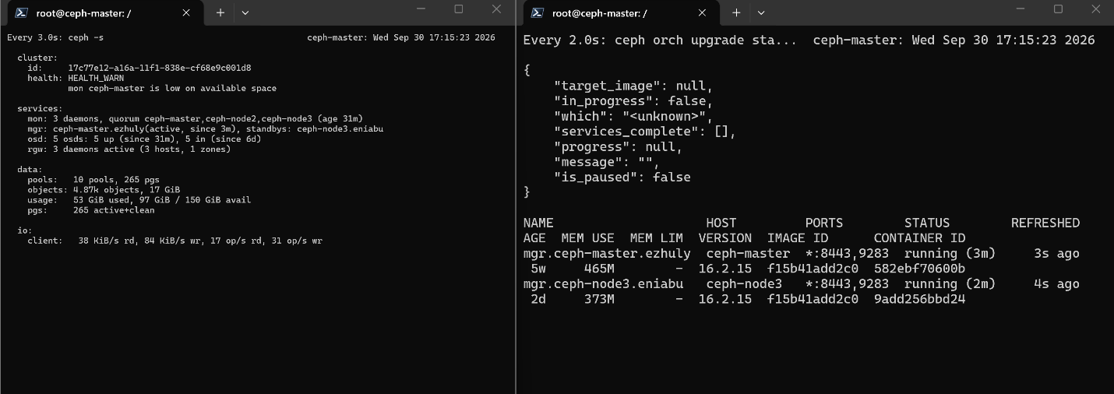
Workload vẫn đang chạy và chưa có error nào xảy ra

